Graph #1

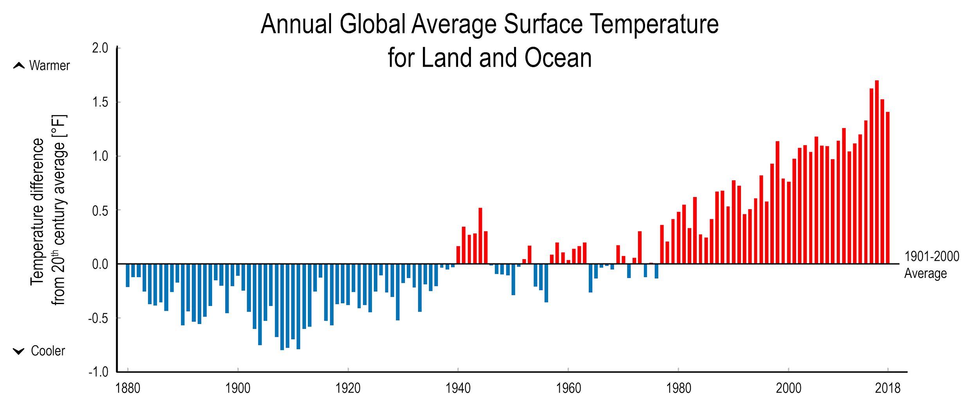

**Figure 1:** Global temperature anomalies from 1880-2018. This data set uses measurements taken by thermometers across the world (both land and ocean) to average global temperature. Red bars show temperatures above the long-term average, and blue bars indicate temperatures below the long-term (100-year) average. (Figure source: Adapted from National Climate Assessment, 2018; updated from Karl et al. 2009).

Graph #2

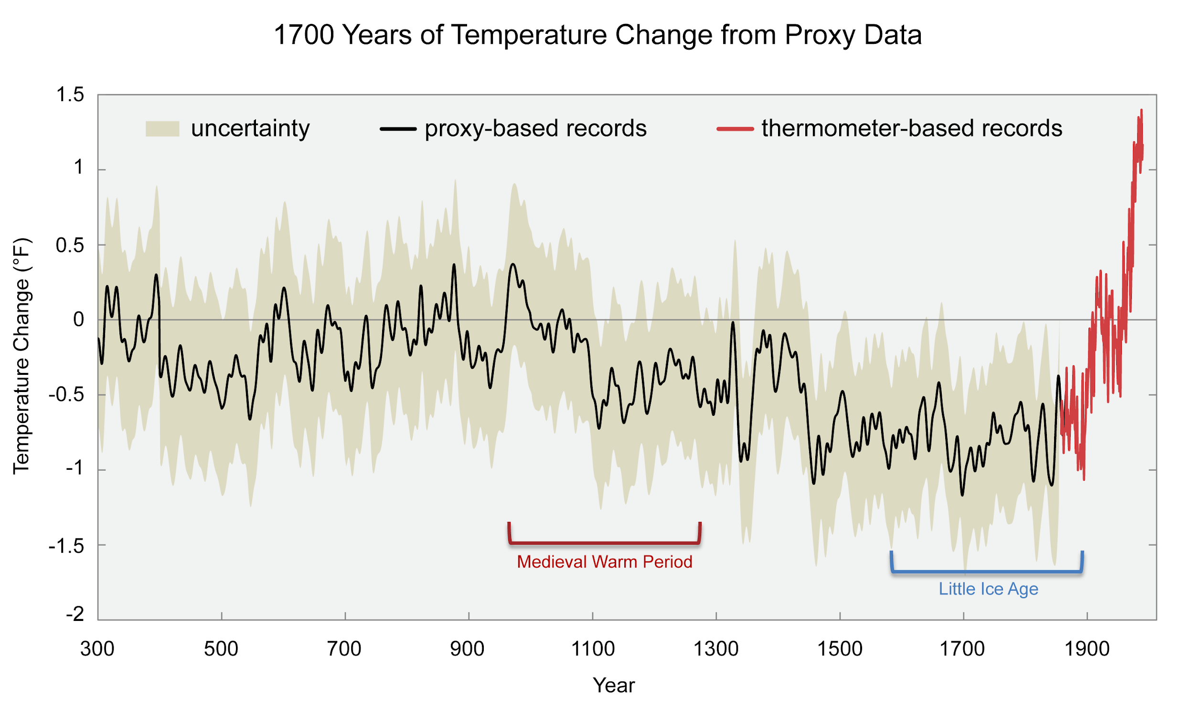**Figure 2:** Using “proxies”, scientists can determine what the air temperature was before people used thermometers regularly. Proxies include tree rings, sediment, and ice records that all store chemical information about the air during historical times. This figure shows changes in the temperature of the Northern Hemisphere compared to the 1961-1990 average temperature. The black line shows data from proxies. The red line shows data from thermometer measurements. The shading represents the uncertainty range. (Adapted from the [National Climate Assessment Climate Science Supplement](https://nca2014.globalchange.gov/report/appendices/climate-science-supplement), 2014; Soure: Adapted from Mann et al., 2008)

Graph # 3

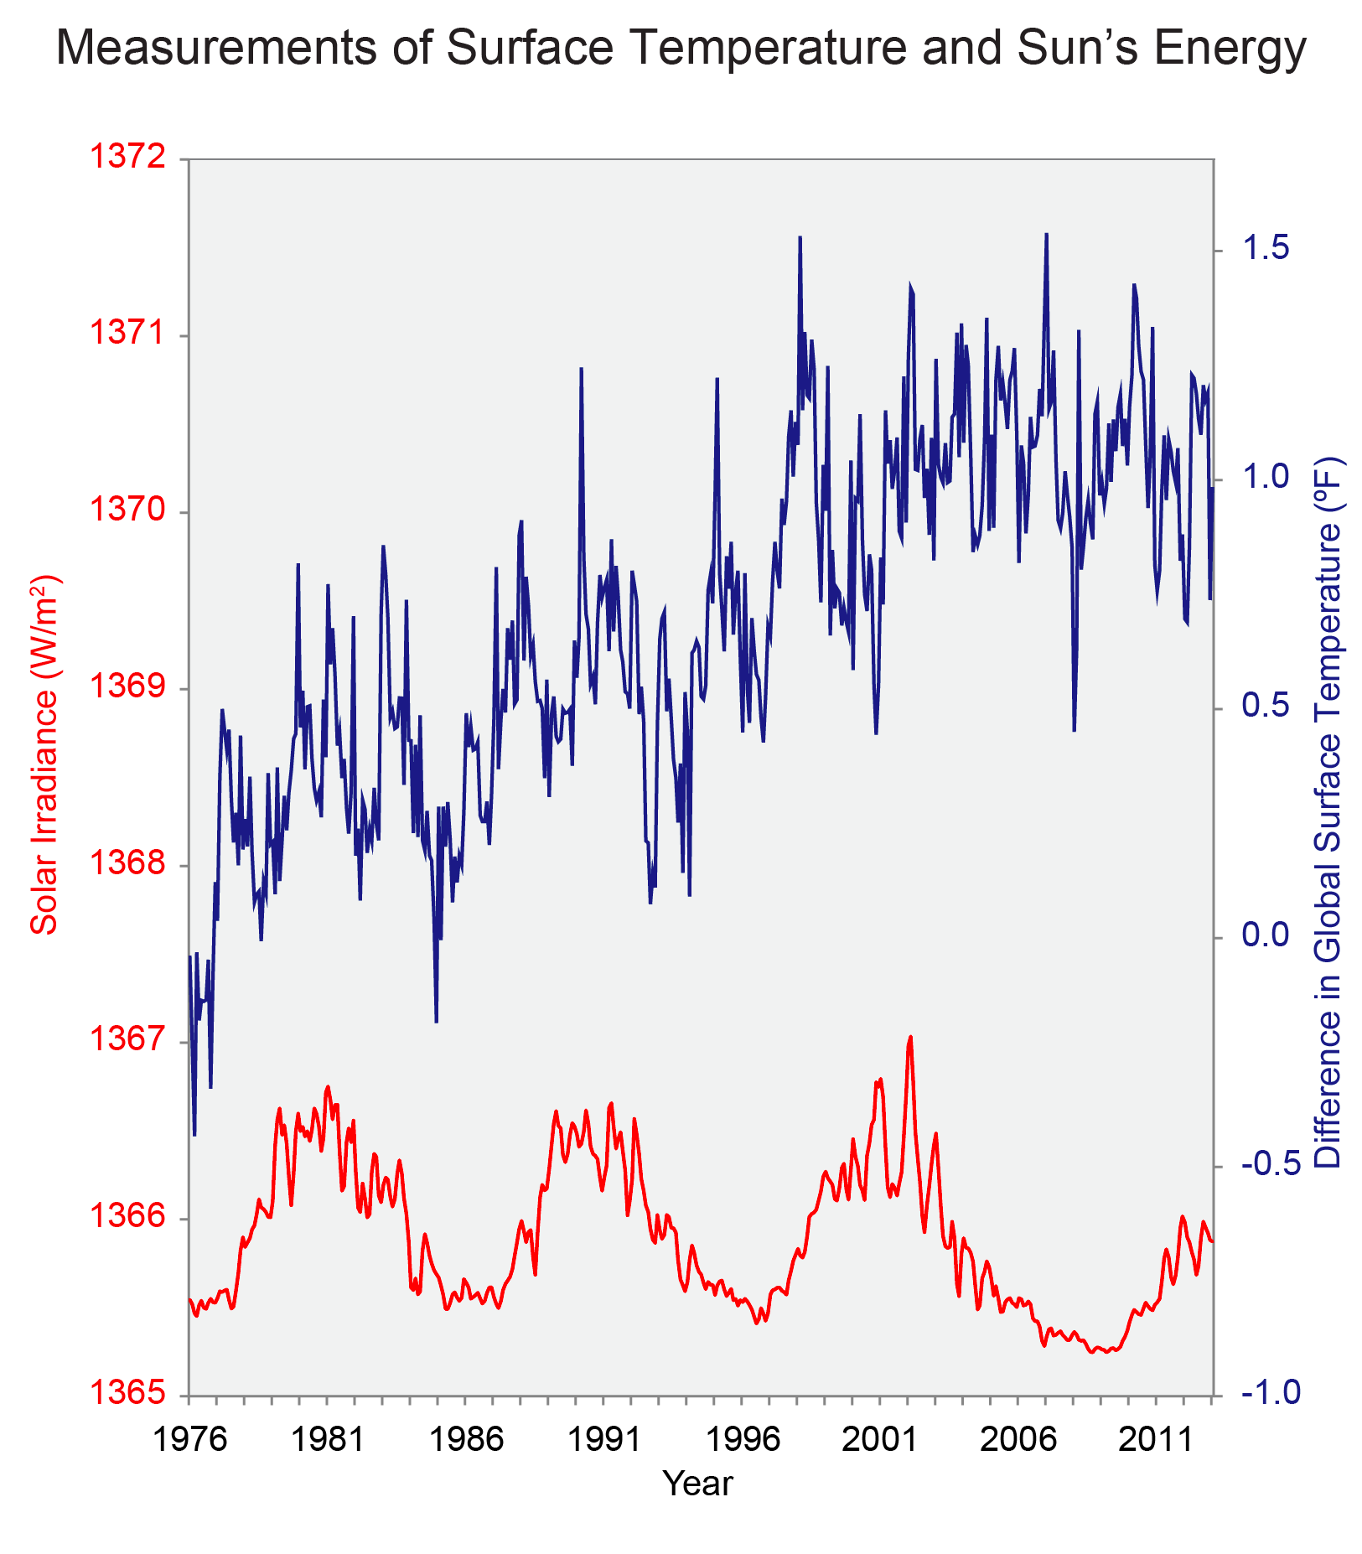

**Figure 3:** Changes in the global surface temperature (blue) and the solar flux (red) since 1900. Temperature is relative to the 1961-1990 average. Solar flux is relative to the total average irradiance from the sun (~1360 watts per square meter). The temperatures are based on thermometer observations of the Earth’s surface temperature, while the solar flux at the top of Earth’s atmosphere is based on satellite observations starting in 1978 and on proxy observations before then. (Adapted from the National Climate Assessment, 2014; Figure source: NOAA NCDC / CICS-NC).

Graph #4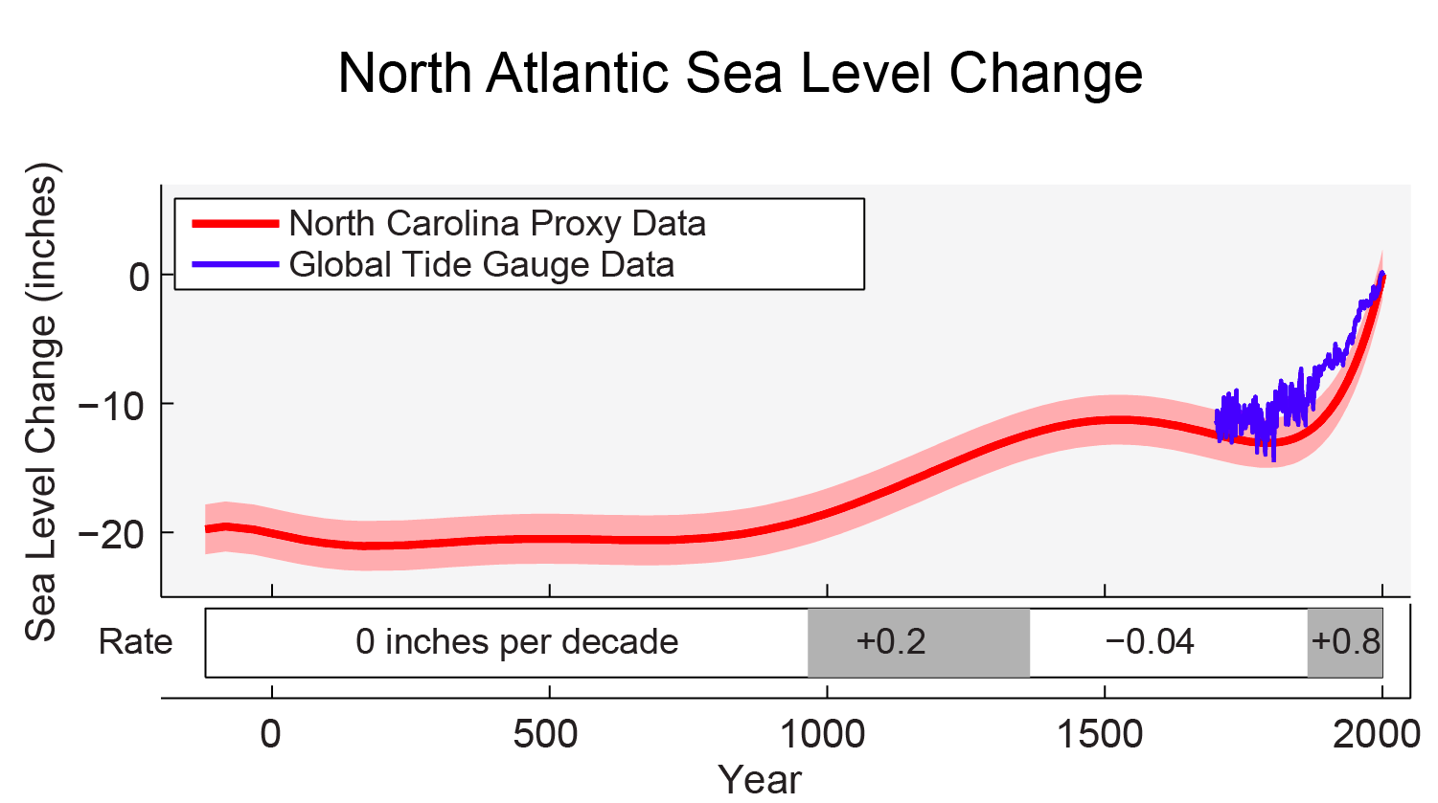

**Figure 4:** Sea level change in the North Atlantic Ocean relative to the year 2000 based on data collected from North Carolina (red line, pink band shows the uncertainty range) compared with a reconstruction of global sea level rise based on tide gauge data from 1750 to present (blue line). (Adapted from the [National Climate Assessment, 2014](https://nca2014.globalchange.gov/report/appendices/climate-science-supplement); Figure source: NASA Jet Propulsion Laboratory). **IMPORTANT NOTE: The graph below is a zoomed in portion of the blue portion of the graph from above.

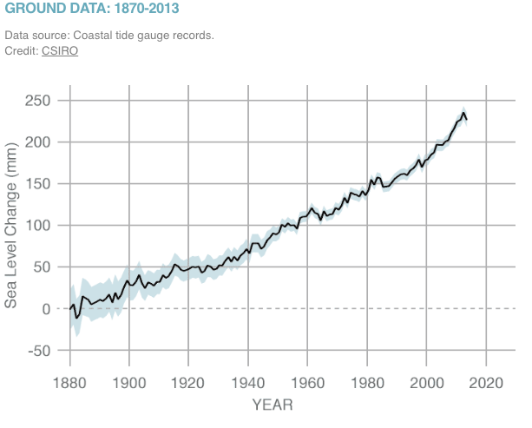

Graph #5

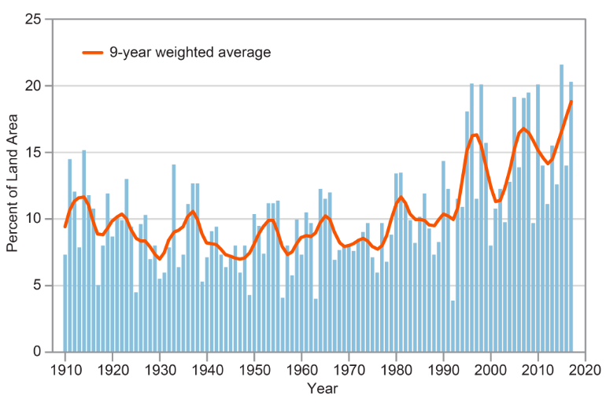**Figure 5 (above):** This figure shows the percent of land area in the contiguous 48 states experiencing extreme one-day precipitation events between 1910 and 2017. The bars represent individual years, and the orange line is a nine-year weighted average. (Adapted from [EPA, 2016](https://www.epa.gov/climate-indicators/climate-change-indicators-heavy-precipitation))

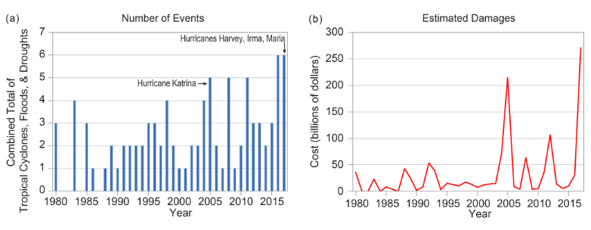

Graph #6

**Figure 6:** The colors on the map show annual total precipitation changes for 1991-2012 compared to the 1901-1960 average. The bars on the graphs show average precipitation differences by decade for 1901-2012 (relative to the 1901-1960 average) for each region. The far right bar in each graph is for 2001-2012. (Adapted from [National Climate Assessment, 2014](https://nca2014.globalchange.gov/report/our-changing-climate/precipitation-change); source: Peterson et al. 2013).

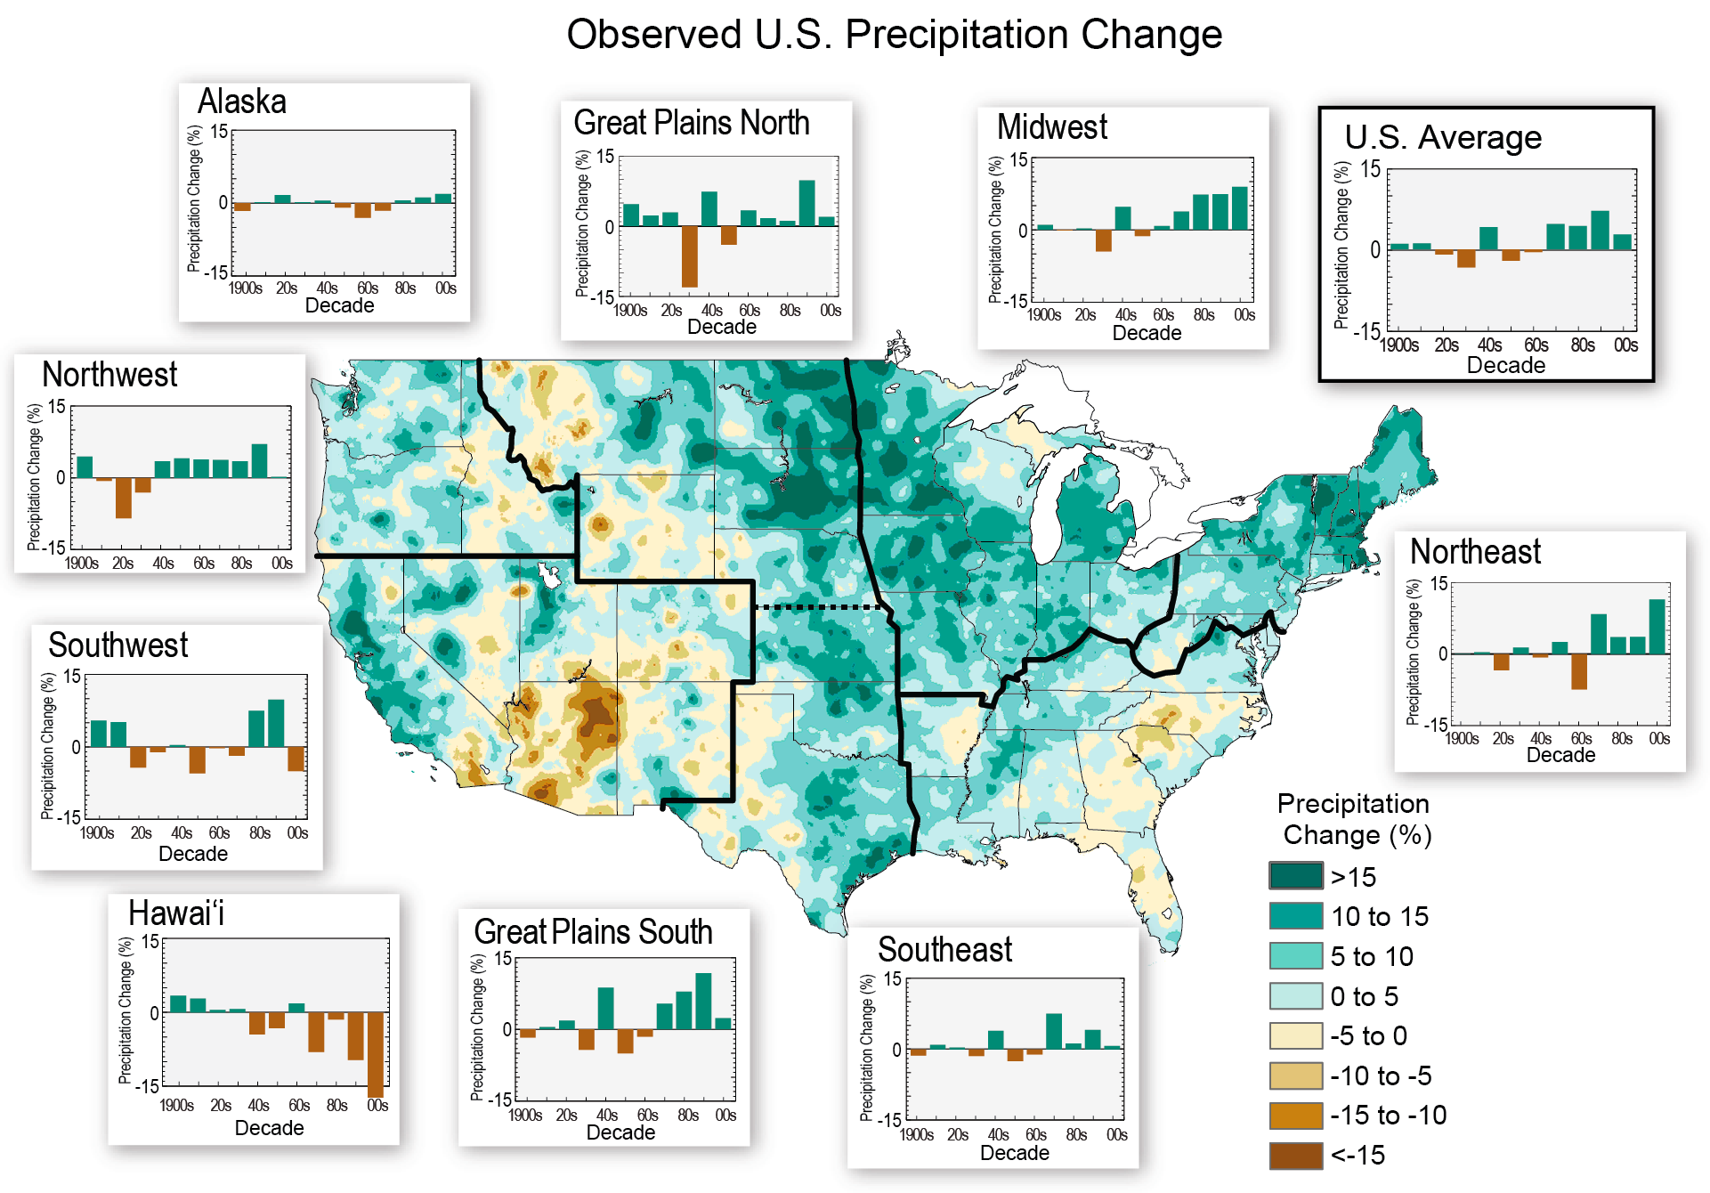

Graph #7

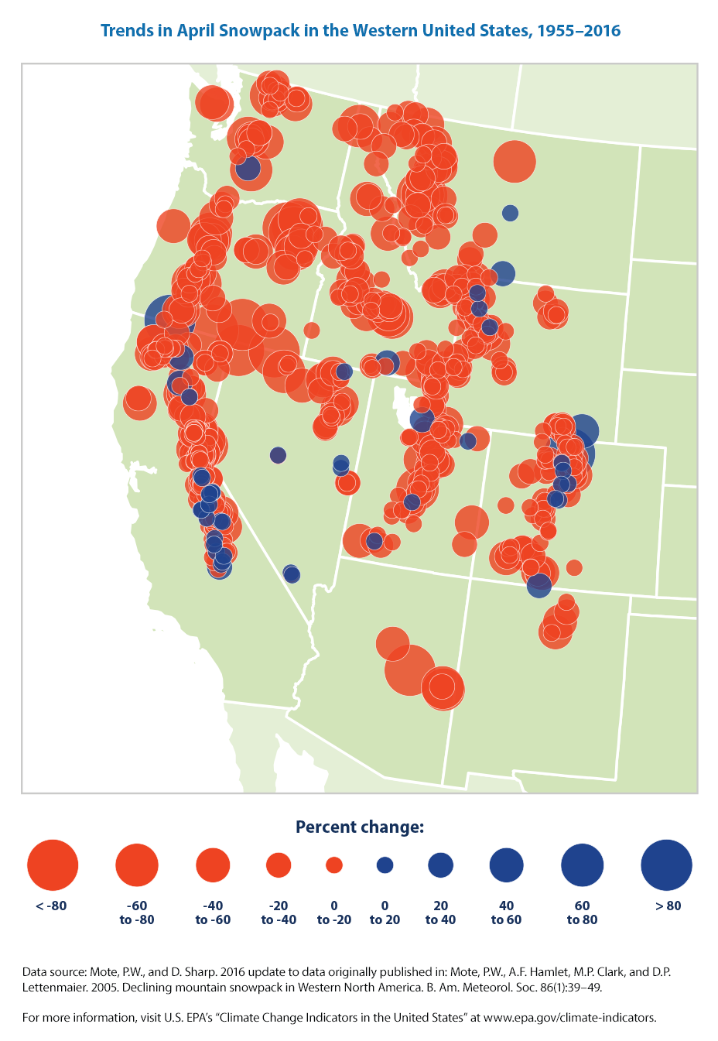

**Figure 7:** This map shows trends in April snowpack in the western United States, measured in terms of snow water equivalent. Blue circles represent increased snowpack; red circles represent a decrease (Adapted from [EPA, 2016](https://www.epa.gov/climate-indicators/climate-change-indicators-snowpack); Data source: Mote & Sharp, 2016)

Graph #8

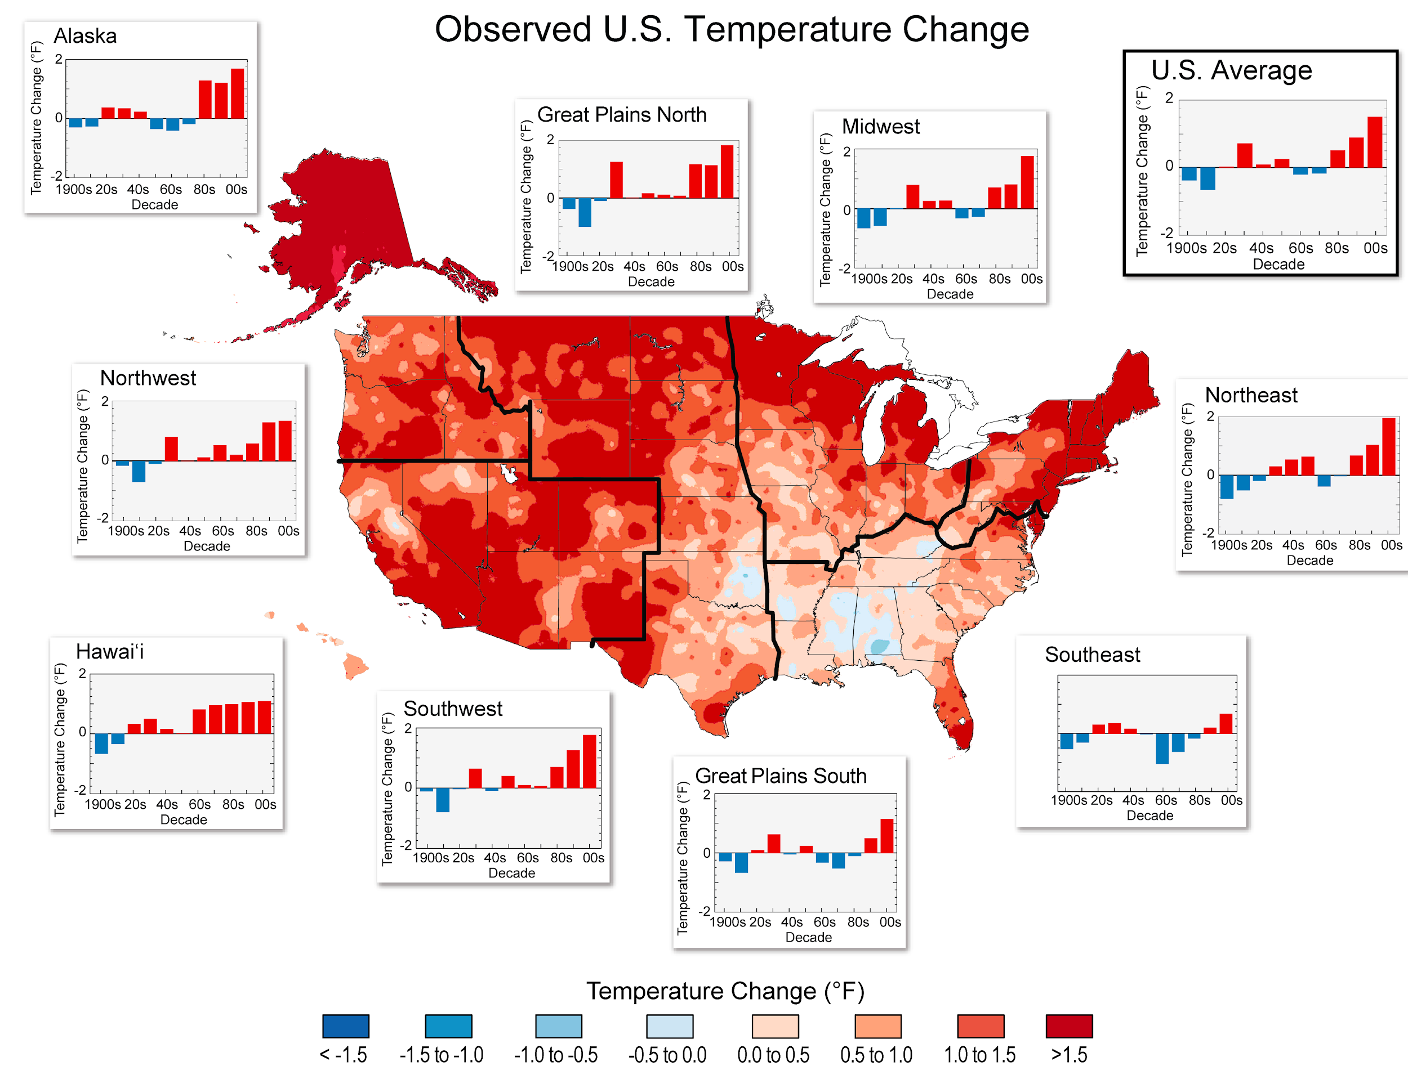

**Figure 8:** The colors on the map show temperature differences between the 22-year period from 1991-2012 and the 1901-1960 average. The bars on the graphs show the average temperature changes by decade for 1901-2012 (relative to the 1901-1960 average) for each region. The far right bar in each graph (2000s decade) includes 2011 and 2012. (Adapted from the National Climate Assessment, 2014; Figure source: NOAA NCDC / CICS-NC).

Graph #9

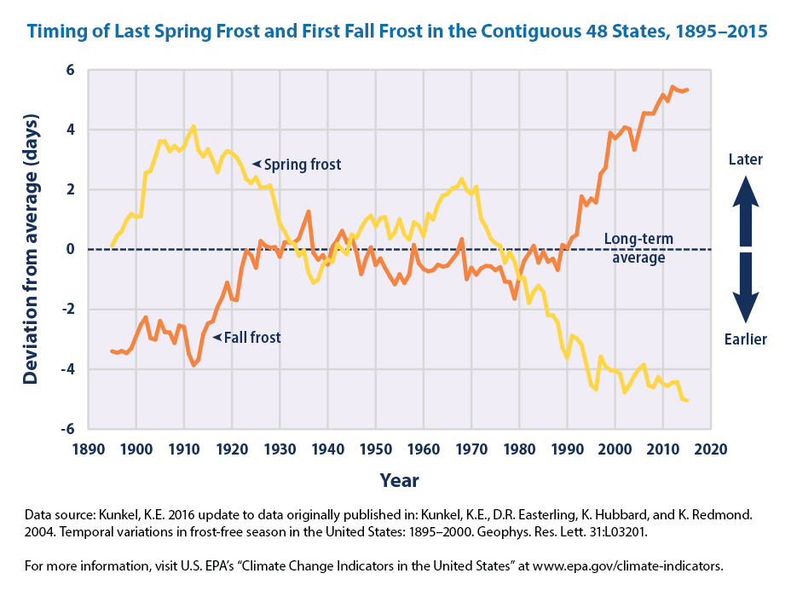

**Figure 9:** This figure shows the timing of the last spring frost and the first fall frost in the contiguous 48 states compared with a long-term average. Positive values indicate that the frost occurred later in the year, and negative values indicate that the frost occurred earlier in the year. The lines were smoothed using an 11-year moving average. Choosing a different long-term average for comparison would not change the shape of the data over time. (Adapted from [EPA, 2016](https://www.epa.gov/climate-indicators/climate-change-indicators-length-growing-season#ref5); Data source: Kunkel, 2016)

Graph #10

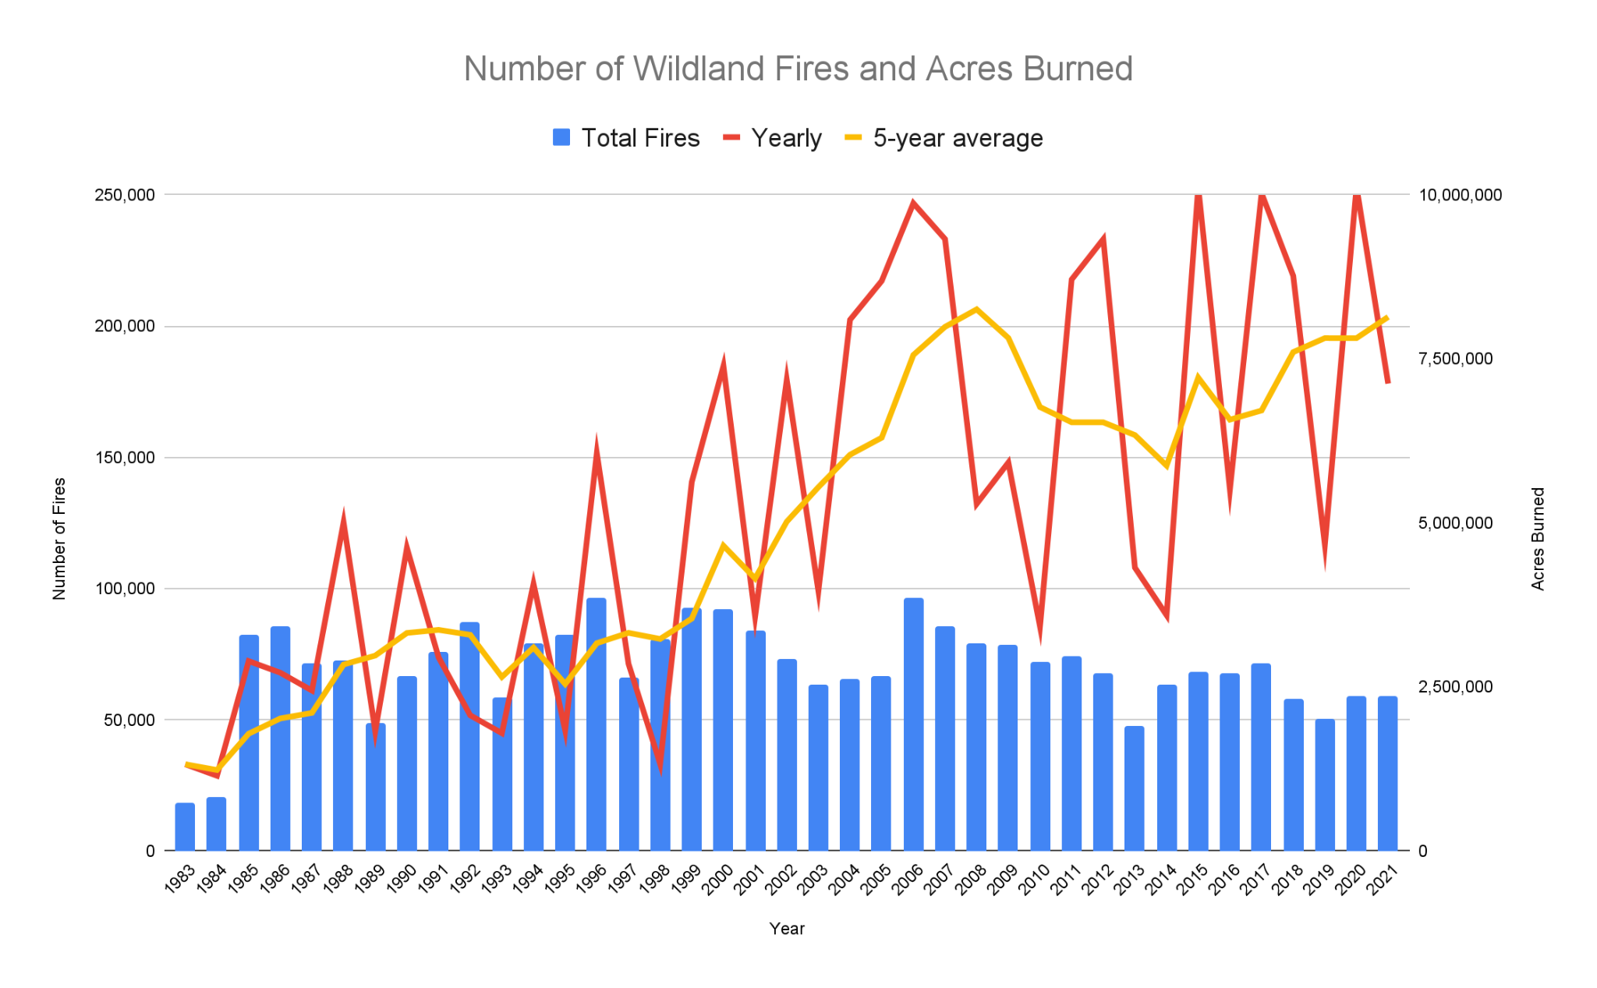

**Figure 10:** This graph shows the total number of fires in the United States by year (blue bars) and number of acres burned in these fires (red and yellow lines). In recent years, now that both climate change and the effects of a century of fire suppression have combined, we have much larger and more intense (“bad”) fires than before. Source: *Statistics: Wildfires and Acres*. (2021). Nifc.gov; National Interagency Fire Center. <https://www.nifc.gov/fire-information/statistics/wildfires>